**IC 201P – Design Practicum**

**PlasBot**

**Tackling the Plastic Problems in Oceania**

|  |  |
| --- | --- |
| Tanmay.M (B19252) | Piyush (B19179) |
| Sourav Sehgal (B19059) | Ayuj Panchal (B19099) |
| Nikhil(B19217) | Pritish Chugh (B19187) |

**Under the supervision of**

Dr. Hitesh Shrimali, hitesh@iitmandi.ac.in

Dr. Prateek Saxena, prateek@iitmandi.ac.in



**Indian Institute of Technology Mandi**

**Certificate**

This is to certify that the work contained in the project report entitled “PlasBot”, submitted by Group G19 to the Indian Institute of Technology Mandi, for the course IC 201P – Design Practicum, is a record of bonafide research works carried out by them under our direct supervision and guidance.

|  |  |
| --- | --- |
| Dr. Hitesh Shrimali | Signature and Date |
| Dr. Prateek Saxena | Signature and Date |

**Acknowledgements**

We would like to thank Dr. Hitesh Shrimali and Dr. Prateek Saxena for mentoring our project all along and guiding us in the right path. We also thank our group’s TA Mr. Anupam Nigam for maintaining the meetings of our group and mentors.

We would also like to thank IIT Mandi for providing us with such a great opportunity.

**Abstract**

Plastics have been a part and parcel of our lives. Starting from food packaging to fabrics, Plastics can be found in almost everything. The plastic items that we discard eventually find their way into the water bodies. When these plastic products reach the water bodies, they cause irreparable damage to both marine and human life. Being non-biodegradable, they cause extensive problems like aquatic life endangerment, algae blooming and many others. Thus, plastic treatment in water bodies has become the need of hour. Our Project PlasBot is a step in this direction. PlasBot is semi-automatic as for tackling floating plastics, PlasBot works autonomously whereas for under water operations, manual instructions are required. The under-water operations were made manual in order to avoid any threats to flora and fauna of the water bodies**.** PlasBot is much better than the existing products as the existing products and patents cannot be used at small scale. They can be used only in oceans and big rivers and are not effective at banks or in lakes while PlasBot is intended to work effectively at small scale also. Since, clean water bodies have a direct impact on our livelihood, PlasBot is going to make our life much easier.

**Contents**

Page.no

* Acknowledgements - ii
* Abstract - iii
* List of Figures - v
* List of Tables - vi
* Abbreviations - vii
* Chapter – 1 - 1
* Chapter - 2 - 4
* Chapter - 3 - 8
* Chapter - 4 - 12
* Chapter - 5 - 16
* References - 26

**List of Figures**

Figure 1: Mind map for implementation of PlasBot

Figure 2: PlasBot architecture

Figure 3*:* Orthographic projection of Model 1

Figure 4, 5, 6*:* Left view, Front view and Top view of Model 1

Figure 7*:* Orthographic Projection of Model 2

Figure 8, 9, 10: Left view, Front view and Top view of Model 2

Figure 11: Overview of Mechanical and Electrical components

Figure12:Gantt Chart

**List of Tables**

Table-1: Billing of Materials

Table-2: Decision Matrix

**Abbreviations**

* GTAW = Gas Tungsten Arc Welding.
* 3DP = 3D Printing.
* SWOT = Strengths, Weaknesses, Opportunities, Threats.
* PlasBot = Name given to the project.
* PCB = Printed Circuit Board
* FOV = Field of View

**Chapter 1**

**Introduction**

1. **Background of the problem**  
   Water is one of the most essential resources that almost every species on earth needs and should save every drop of it. But on the other hand, water pollution is increasing day by day in water bodies and it is very difficult for marine life to survive also there is less fresh water available for consumption. From a study, approximately 165 million tons of plastic wastes were estimated to be present in the oceans of the world. Typically, plastics in the oceans can degrade within a year but not completely. During this plastic degradation process, toxic chemicals like polystyrene and BPA can be released into the water causing water pollution. Wastes found in the oceans are made up of approximately 80% plastics. Hence it is needed to separate/filter water from the garbage/plastics present in it.
2. **Scope of the problem**

As we all know that only 0.5-1% of the total water available on earth is fresh water and we are also polluting that water also by throwing plastic garbage in rivers, lakes etc. Plastics not only pollutes the water but also kills the marine life present in it. Hence, we have found a way to separate the plastic garbage from the water bodies by the means of a robot ‘PlasBot’ which can collect plastic garbage from both under and over water. We used different methodologies and many solutions and came to a conclusion to build the Bot which will clean the plastic waste from water bodies and very beneficial for aquatic flora and fauna. We also designed it in a way so that it is efficient, minimum wastage and minimum use of manpower. The beneficiaries will be both governmental as well as non-governmental organizations who are working towards cleaning of oceans, rivers, etc.

1. **Design philosophy used in this report**

In this report, we first briefly discussed about our problems, various solution methodologies for them, beneficiaries and why we chose to build it. After that we identified different products which were already in the market, similar to our product and their comparison with our product. Next, we discussed how we narrowed down to our one product from various different products through rigorous analysis. After that, the detailed design of our product, explaining each part of the product was done. At last, the budget analysis was done considering various constraints like the maximum amount to be used, minimum wastage etc.,

1. **Problem statement**

To cleanse the water bodies of plastic waste both of floating and underwater nature thus leading to various benefits such as cleaner environment for the aquatic flora and fauna.

1. **Beneficiaries (Intended market)**

Cleaning the water bodies is one of the major problems. If we could arrive at an efficient solution, it will directly solve a lot of major environmental issues. So PlasBot is intended for the use of various governmental as well as non-governmental organizations who are working towards cleaning of oceans, rivers, etc. thus solving the issue of plastic present inside water. PlasBot would help the organizations to efficiently tackle the problem of plastic present inside water which is one of the major concerns related to the environment.

1. **Organization of this report**

The report is divided into five sections. The following are the topics covered in each chapter:

**Chapter 1**:

* The background of the situation for which PlasBot was built, the scale of the problem, and the influence PlasBot has on the environment.
* The design philosophy that guided the creation of this report.
* A summary of the problem that PlasBot will be utilised to solve.
* PlasBot's beneficiaries/target market, as well as the structure of this report.

**Chapter 2**:

* We examined the present products in the market, as well as their essential features.
* PlasBot is compared to current products in the market, demonstrating how PlasBot outperforms previous technologies.
* Discussion of the issues that are involved with existing alternatives, as well as how PlasBot differs from the competition.

**Chapter 3**:

* We've talked about how we narrowed down the first problem statement to the current one.
* A discussion of the numerous brainstorming sessions that assisted us in identifying all of the possible solutions to the challenge, as well as a mind map depicting the various characteristics of PlasBot.
* Some of the most viable concepts were given, as well as a decision matrix outlining the criteria by which we chose the current idea and rejected all others.
* The problem's "proposed solution" is offered at the end.

**Chapter 4**:

* The product architecture.
* An overall block diagram emphasizing the product's functionality as well as the design concept's functioning principle and practicality.
* A system-level design that discusses how each subcomponent or module interacts with each other and the purpose of each subcomponent at the product level.
* PlasBot's design configuration, which involves material selection, manufacturing method, modelling, and part sizing, among other things.
* And, finally, the outcomes of the subjects presented in this chapter.

**Chapter 5**:

* Chapter 5 includes the Bill of Materials (BOM).
* Ready for execution drawings including the material description. The electrical and mechanical components are discussed separately.
* An overview about the manufacturing Process description that includes the plan of fabrication of individual parts.
* Assembly of all the components.
* Limitations and constraints that must be overcome from both a product and fabrication perspective.
* Scheduling tasks using a Gantt chart in order to complete them in the shortest amount of time possible.
* Contributions from each team member, as well as a conclusion of the project's findings.

The references which have been used for the making of this report are included at the end.

**Chapter 2**

**Market Research**

1. **Existing products in the market**:
2. **Ro-Boat**

Ro-Boat is an automated robot developed by Omnipresent Robot Technologies driven by a vision to harness technology to clean up our water bodies in line with the Prime Minister’s vision, and the 17 SDGs of the UN.

**Key Features:**

* AI driven waste detection and collection.
* Controlled by operator up to a range of 5 Km or automated mission.
* Light weight and easily transportable; ideal for time and region responsive missions
* Endurance of 2 hours in one charge
* Capable of extracting 5 kgs of waste per hour and 12 hours of continuous operations (using rechargeable batteries) under varying conditions.
* Can operate close to shore in shallow waters.
* Records path of operations for post mission analysis
* Offers ability to collect samples from different locations for water body profiling.

1. **Kerala’s sewage-cleaning robot- Bandicoot**

The Bandicoot robot project is funded by the Kerala Financial Corporation and venture capitalist Unicorn India Ventures for the purpose of sewage cleaning.

**Key features:**

* The Bandicoot has four limbs and a bucket system attached to a spider-web extension that goes into the sewer, shovels the waste and collects it in the bucket, which is then lifted out.
* Has Wi-Fi and Bluetooth modules.
* The robot is powered by pneumatics since using heavy electronic equipment inside the manhole may inflame the explosive gases present in the manhole.
* The robot monitors the manholes through pictorial representations, inspects conditions, including gaseous information and blocks and then does the clean-up.

1. **Hong Kong startup’s Clearbot**:

'Clearbot' can be operated remotely or autonomously to remove trash from lakes, canals, harbors or any other water body.

**Key Features:**

* This robot uses a computer vision system to spot the trash.
* It collects pieces of litter floating on water bodies.
* The trash goes through the open bow of the robot and is collected in a mesh bin with the help of a conveyor belt system.
* The robot could be operated for 48 hours once it is fully charged capable to carry a 10 kg of waste.
* The company claims that in comparison to any current solution, Clearbot is 15 times cheaper, has five times more reach and removes two times more trash daily.

**d) Seaswarm:**

Seaswarm are autonomous water robots that are capable of cleaning up an oil spill. It has been developed by MIT. The spilled oil is collected by the conveyer as the robot travels.

**Key Features:**

* The robots float on the water and with the help of a very special oil-absorbing nanomaterial that is applied on a conveyor belt they collect the oil.
* It is an autonomous water bot.
* Seaswarm uses a photovoltaic powered conveyor belt.
* The belt is made up of nanowire mash which helps to collect the oil.
* Different bots communicate with each other using GPS, Wi-Fi to autonomously.

**e) ORCA:**

This bot is designed to work remote-controlled or to run on a pre-programmed route. It is designed to collect the rubbish on the surface floating or just beneath the surface of the water body. It was not meant to collect big pieces of waste but only the small plastic bags etc.

**Key Features:**

* Bot is capable of collecting 50kg of rubbish in an hour.
* It uses polymer lithium battery which helps it run for about 4 hrs.
* It is designed to collect the rubbish that is present only on the surface and not deep inside the river body.
* The bot is fitted with cameras, radar and ultrasound to aid it in navigating autonomously.

1. **Comparison with the current products/similar technologies that exist in the market:**

* PlasBot is semi-automatic bot used for tackling floating plastics, PlasBot works autonomously whereas for under water operations, manual instructions are required. On the other hand, existing products either are mainly remote controlled or are preprogrammed to follow a particular path.
* PlasBot uses vacuum pump to suck the garbage while existing products either collect manually or with the help of complex mechanisms like conveyer belt thus guaranteeing that the bot collects the garbage effectively.
* The considerable battery life of PlasBot is expected to be much higher than most of the existing products because of comparatively smaller size of the bot and simple operations.

1. **Problems associated with the existing alternatives: -**

* Most of the products that are existing are mainly remote controlled or are preprogrammed to follow a particular path.
* The already existing products are quite expensive and cannot be afforded by everyone.
* Due to big size of the existing products, it is difficult to collect garbage at the banks.
* The existing products and patents cannot be used at small scale. They can be used only in oceans and big rivers.

1. **How PlasBot is different from the existing products:**

* PlasBot is semi-automatic as for tackling floating plastics, PlasBot works autonomously whereas for under water operations, manual instructions are required. The under-water operations were made manual in order to avoid any threats to flora and fauna of the water bodies.
* PlasBot can be afforded by anyone who wishes to carry out the treatment of plastic waste in water bodies in the surroundings.
* Since the intended size of PlasBot is comparatively small, it will be effective in eliminating plastic wastes from banks also.
* PlasBot can be used in treating plastic waste at small scale in ponds and small rivers also.

**Chapter 3**

**Conceptual Design**

1. **First Problem Statement to the Current Problem Statement**

The very first problem statement that was proposed was to design/build a project for this design practicum course that will make some impact in reducing the pollution, the damage that is being caused to the environment. We discussed about what type of problems are being faced by us in the current scenario and came up with an idea of building a project that will help in reducing pollution caused by the plastic waste that in one way or another gets dumped/ reaches the water bodies. We discussed among us that in what ways could we contribute to help the environment. We discussed a few ideas, discussed the pros and cons of what we will be constructing, its feasibility and if our project/bot itself will be causing any damage to the environment.

After all these discussions we finally decided to build our “PLASBOT”, our final project.

1. **Brainstorming and Idea generation**

In the process of reaching our final problem statement, we had many sessions in order to resolve the difficulties and problems that could arise on real life implementation of PlasBot.

We had to decide on functional requirements of PlasBot and issues related to designing of PlasBot keeping in mind the efficiency, accuracy and precision.

Following mind map describes our process to identify all the various means of solving the problem:

Figure 1: Mind map for implementation of PlasBot

1. **Most viable ideas proposed**:

After all of members of our team proposed 100 ideas each, we filtered them out and narrowed them down to roughly 20 problems. The criteria for filtering these was quite simple. Each member was asked to propose the best of the ideas they proposed out of 100. Roughly everyone gave 20 – 25 problems from there set. After filtering them out each member was asked to go through the problems proposed by the rest of the members and give his opinion if he/she thought that a particular idea was good or not.

After filtering all these, we were left with roughly 8 ideas, of which we chose the final one. Those ideas were:

* A health monitoring gadget for older people.
* Automatic seed sowing with parameters of distance, soil type.
* Effective way to tackle the problem of plastics in water bodies.
* Obstacle detector walking stick for blind people
* Product that informs about the fertility of soil, its conditions that would imply which crop could be sowed.
* Protecting women during distress times, like giving out emergency signals even in low connectivity places.
* Automatic switching of stoves etc. when there is a leakage in gas cylinder.
* A way to automatically prevent dust entry through windows but simultaneously increasing the quality of the air that enters inside the house.

All these filtering of ideas was done after looking into so many aspects like the social impact, feasibility, accessibility, economic feasibility, time required to build it, reach to users, SWOT analysis and many more. After all these discussions, we finalized “PlasBot” to be our final project after considering all the factors stated above.

1. **Decision matrix and Final Problem Statement:**

After considering the aspects like social impact, feasibility, accessibility, economic feasibility, time required to build it, reach to users and SWOT analysis and with discussion with group and mentors, PlasBot was finalized as our final product.

**Decision matrix:**

Scale: 0 (Very Less Significant) -5 (Very Significant)

|  |  |  |  |  |  |  |  |
| --- | --- | --- | --- | --- | --- | --- | --- |
| Idea | Social Impact | Feasibility | Accessibility | Economic Feasibility | Time required to build it | Reach to Users | SWOT analysis |
| A health monitoring gadget for older people. | 5 | 3 | 3 | 3 | 2 | 4 | 4 |
| Automatic seed sowing with parameters of distance, soil type. | 5 | 3 | 2 | 3 | 2 | 4 | 4 |
| Effective way to tackle the problem of plastics in water bodies. | 5 | 4 | 5 | 4 | 4 | 5 | 4 |
| Obstacle detector walking stick for blind people. | 4 | 4 | 4 | 5 | 4 | 4 | 3 |
| Product that informs about the fertility of soil, its conditions that would imply which crop could be sowed. | 5 | 3 | 3 | 2 | 1 | 4 | 4 |
| Protecting women during distress times, like giving out emergency signals even in low connectivity places. | 5 | 3 | 3 | 3 | 1 | 5 | 3 |
| Automatic switching of stoves etc. when there is a leakage in gas cylinder. | 4 | 3 | 3 | 3 | 3 | 3 | 2 |
| A way to automatically prevent dust entry through windows but simultaneously increasing the quality of the air that enters inside the house. | 3 | 3 | 3 | 3 | 4 | 3 | 3 |

**Final Problem statement**

To cleanse the water bodies of plastic waste both of floating and underwater nature thus leading to various benefits such as cleaner environment for the aquatic flora and fauna.

**Chapter 4**

**Embodiment and Detailed Design**

1. **Product architecture –** The PlasBot block diagram is shown in figure 2. The semi-autonomous feature of the PlasBot is selected in order to increase its working efficiency given the power, vision constraints. The floating garbage on the water body is collected autonomously using different computer vision, deep learning aspects whereas when underwater, the bot driven using wireless remote control. Considering the low lighting, translucence conditions for underwater operations, using computer vision methods for the identification, gathering the plastics/garbage will become a heavy computational task along with lower accuracy which can also lead to harming flora and fauna. Thus, manual control was chosen for underwater operations.



Figure 2: PlasBot architecture

1. **System-level design** –

* **Functionalities of each component:**
  + - **Raspberry pie-** To control all other components.
    - **Wi-Fi module-**To control the bot wirelessly.
    - **Depth sensor-**To measure the depth of the water.
    - **Video camera-**To show real time videos of the objects underwater.
    - **Capacitive sensor-**To avoid obstacles and rocks.
    - **Net attached at the back-** To collect the garbage and allow water to pass.
    - **Vacuum pump-** To suck the water with garbage.
    - **Remote control-** To wirelessly send signals to the bot.
    - **Lcd display-** To view the video which camera sends underwater.
    - **Batteries-**To power the bot.
    - **Motor-** To move the bot over and underwater.
    - **Weight sensor-**To measure the weight of the plastic collected in the net.
  + **Interaction of every component with each other**
    - **For overwater-**First the raspberry pie signals the depth sensor to check the depth of water and as it detects that the water is shallow then it signals the PlasBot to search for garbage overwater. At this time, the capacitive sensor is also active to detect rocks and avoid collision. Now as the bot find garbage the vacuum pump starts and sucks the water with garbage which is then collect in the net attached at the back. And at the end when the net is full the weight sensor signals the Raspberry Pi to stop the bot from further collecting the garbage.
    - **For underwater-** First the raspberry pie signals the depth sensor to check the depth of water and as it detects that the water is deep then it signals the PlasBot to search for garbage underwater. At this time, the video camera turns on and starts displaying video in the LCD screen. As the bot is manually controlled underwater, the remote controller is used to control the bot. And at the end when the net is full the weight sensor signals the rasp pi to stop the bot from further collecting the garbage and return to the shore.

1. **Design configuration -** Shape and general dimensions or sizes are established to the components that are defined in product architecture. It is largely depended on the three-dimensional constraints that define the envelope in which the product operates and the product architecture. This would be a preliminary selection of material, manufacturing process, modelling, sizing of parts etc.

The shape of the PlasBot will be of boat shape with aerodynamic body is front to cut water and a box type net is attached at the back of the bot. The outer modelling will be done of aluminum with a water prof body from inside where all other components will be there.

1. **Detailed design –**

* **Electrical/Electronic aspect:** During operation of PlasBot we need to detect the plastic wastage, obstacles in the path so that the Bot will function efficiently without harming itself or the surroundings. For this task, sensors are used that detect the objects in the view field of the Bot. Now we need a processing unit that takes control of various processing tasks like telling when to maneuver around obstacles, when to stop collecting garbage incase the garbage bag is full and many of such things. For this task RaspberryPi (a Microcontroller) was used along with different elements like capacitors, resistors etc., The whole circuit does all the task control work which in turn makes the Bot do what it is intended to do. All of this consist of the electronic aspect of PlasBot.
* **Software part:** The algorithm thatwe will follow the same pathway as shown in figure 2. When the Bot is floating, the sensors start up and detect if there is any obstacle present in its Field of View (FOV). In most of the water bodies, all the obstacles that float on the water will either be wastage generated by humans or broken plants, algae or rocks. Since a small rock does not have a chance of floating, we can neglect this test case from our analysis. If any object detected that is as big as the FOV of the Bot, be it plastic waste or a protruding bed rock, the Bot does not have the capacity to carry it over hence will be programmed to go around it. The rest of the cases where the object is comparatively smaller can be classified by the Bot as wastage and picked up. In order to avoid blocking issues if a particular object cannot be picked over, the Bot will send the user a signal to switch over to manual mode to pick it up and if the request is timed out, it will just ignore it. This is to make the maximum utilization of the battery life of the bot. The under-water operation of the bot will be done manually in order to avoid any error by automated Bot to the in-order water fauna. It will also be programmed to indicator when the garbage carrier is full and needs to be cleaned and when the battery life of the bot is about to run out. This is obviously to avoid issues like unexpected drowning of the bot and/or sudden switch off and getting stranded out of the reach in the water body.
* **Mechanical Aspects:** The whole outer body design of the PlasBot is designed in such a way that it is significantly reduces the drag due to water flow and thus resulting in efficient use of power required. Instead of automating most of the tasks of the PlasBot which will increase the computational load on the microcontroller, some of them can be overcome by simple tweaks to the design of PlasBot. For example, instead of using computer vision to detect where the plastic is all the time, we can just use a wider opening through which we can filter out the water but capture wastage and send it out to the collector. Such different ideas have been incorporated into the design aspects of the PlasBot.

1. **Results and Discussion**

In this chapter we discussed the detailed design and the process which we followed in connecting all the three major aspects (Software, Mechanical and Electrical/Electronic aspects). The main challenge that we faced was in the Software aspect that lets the Bot function efficiently. Another challenge is the integration of the three aspects together thus making the whole bot function. We solved this challenge by carefully analyzing the problem, forming a block diagram that depicts our needs and putting it all together.

**Chapter 5**

**Fabrication and Assembly**

1. **Bill of Materials (BOM).**

|  |  |  |  |  |  |
| --- | --- | --- | --- | --- | --- |
| **Serial No.** | **Name of Item** | **Approximate Cost per item (in Rs.)** | **Quantity** | **Approximate Cost**  **(in Rs.)** | **Resource Links** |
| **1** | Marine Boat Propeller | 650 | 2 | 1300 | <https://www.amazon.in/dp/B08BHYNK2F/?coliid=I5DXLCPXMD14H&colid=3FCYSYXZ0OQV7&psc=1&ref_=lv_ov_lig_dp_it> |
| **2** | Kriwin Agro Net | 550 | 2 | 1100 | <https://www.amazon.in/dp/B078L18NWG/?coliid=I13ZDXLEASKAIG&colid=3FCYSYXZ0OQV7&psc=1&ref_=lv_ov_lig_dp_it> |
| **3** | Generic jumper Wires Male to Male, Female to Male and Female to Female | 220 | - | 220 | <https://www.amazon.in/dp/B00ZYFX6A2/?coliid=IDSJ76EYBNBMH&colid=3FCYSYXZ0OQV7&psc=1&ref_=lv_ov_lig_dp_it> |
| **4** | Motion sensor | 250 | 3 | 750 | <https://www.amazon.in/dp/B0792FDRHC/?coliid=I7OV4JATDPHWA&colid=3FCYSYXZ0OQV7&psc=1&ref_=lv_ov_lig_dp_it> |
| **5** | Water Level Controller | 400 | 2 | 800 | <https://www.amazon.in/dp/B00RY2MOM4/?coliid=I2C23C4MIDV3H4&colid=3FCYSYXZ0OQV7&psc=1&ref_=lv_ov_lig_dp_it> |
| **6** | Weight sensor | 450 | 2 | 900 | <https://www.amazon.in/dp/B07FD4PXL6/?coliid=I3TU6E7Z1QVG52&colid=3FCYSYXZ0OQV7&psc=1&ref_=lv_ov_lig_dp_it> |
| **7** | Accelerometer and gyroscope module | 450 | 1 | 450 | <https://www.amazon.in/dp/B07DC74795/?coliid=I16OLYBZJTA0LM&colid=3FCYSYXZ0OQV7&psc=1&ref_=lv_ov_lig_dp_it> |
| **8** | Servo robotic gripper | 500 | 2 | 1000 | <https://www.amazon.in/dp/B07PR73Q44/?coliid=I3LVIHVGLJQR77&colid=3FCYSYXZ0OQV7&psc=1&ref_=lv_ov_lig_dp_it> |
| **9** | DC water pump | 450 | 2 | 900 | <https://www.amazon.in/dp/B07HGD9L1Q/?coliid=I1BM5X3GT46BCB&colid=3FCYSYXZ0OQV7&psc=1&ref_=lv_ov_lig_dp_it> |
| **10** | Capacitive proximity sensor | 800 | 3 | 2400 | <https://www.amazon.in/dp/B083N3JDPJ/?coliid=I19V8MB6UT85WQ&colid=3FCYSYXZ0OQV7&psc=1&ref_=lv_ov_lig_dp_it> |
| **11** | Ultrasonic Module distance Measuring sensor | 250 | 3 | 750 | <https://www.amazon.in/dp/B01I1ZTPJC/?coliid=I1GU2QTOFJDABM&colid=3FCYSYXZ0OQV7&psc=1&ref_=lv_ov_lig_dp_it> |
| **12** | Motor Driver Module | 250 | 4 | 1000 | <https://www.amazon.in/dp/B00N4KWYDE/?coliid=I1PKTWLKD0RK0Q&colid=3FCYSYXZ0OQV7&psc=1&ref_=lv_ov_lig_dp_it> |
| **13** | DC Motor | 500 | 4 | 2000 | <https://www.amazon.in/dp/B07J9WKX2C/?coliid=IQ8BEJVWV9YN3&colid=3FCYSYXZ0OQV7&psc=1&ref_=lv_ov_lig_dp_it> |
| **14** | Controller | 800 | 1 | 800 | <https://www.amazon.in/dp/B07MBGKTL3/?coliid=I3DWOUWAJGV8AY&colid=3FCYSYXZ0OQV7&psc=1&ref_=lv_ov_lig_dp_it> |
| **15** | Raspberry pi Camera Module | 2400 | 1 | 2400 | <https://www.amazon.in/dp/B01ER2SMHY/?coliid=I2LO3UCO0NOB40&colid=3FCYSYXZ0OQV7&psc=1&ref_=lv_ov_lig_dp_it> |
| **16** | Raspberry Pi Motherboard | 5710 | 1 | 5710 | <https://www.amazon.in/Raspberry-Pi-Model-Controller-Electronic/dp/B07XT1QJ4S/ref=sr_1_2?crid=19OAY2KCQLAWX&dchild=1&keywords=raspberry+pi+4+4gb&qid=1618232739&sprefix=raspberry+pi+4+%2Caps%2C314&sr=8-2> |
| **17** | PIR sensor | 550 | 2 | 1100 | <https://www.amazon.in/HC-SR501-Infrared-Pyroelectric-Replacement-Raspberry/dp/B08WX9KPQ6/ref=sr_1_6?crid=1INXPYHL13TPQ&dchild=1&keywords=pir+motion+sensor+raspberry+pi&qid=1618232781&sprefix=pir+sensor+for+ras%2Caps%2C322&sr=8-6> |
| **18** | ABS polymer for body construction | 160 (per kg) | - | 400 | <https://www.indiamart.com/proddetail/abs-hrg-granules-18748124612.html> |
| **19** | Power Bank | 1500 | 1 | 1500 | <https://www.amazon.in/20000mAh-Sandstone-Triple-Charging-Delivery/dp/B08HV83HL3/ref=sr_1_3?dchild=1&keywords=power+bank&qid=1618233112&sr=8-3> |
| **20** | Servo motor | 175 | 3 | 520 | <https://www.amazon.in/Robotbanao-Tower-Helicopter-Airplane-Controls/dp/B07D5TVHGK/ref=sr_1_2?crid=2AO74YQJCCWPH&dchild=1&keywords=servo+motor+for+raspberry+pi+4&qid=1618233030&sprefix=servo+motor+for+raspbe%2Caps%2C366&sr=8-2> |
| **21** | PCB Design | 4000 | 1 | 4000 |  |
| **Total Cost** | | | | 30000 |  |

1. **Ready for execution drawings:**

**Body of the bot:** Aluminium would be used to make the chassis of the bot since it is light weight and durable.

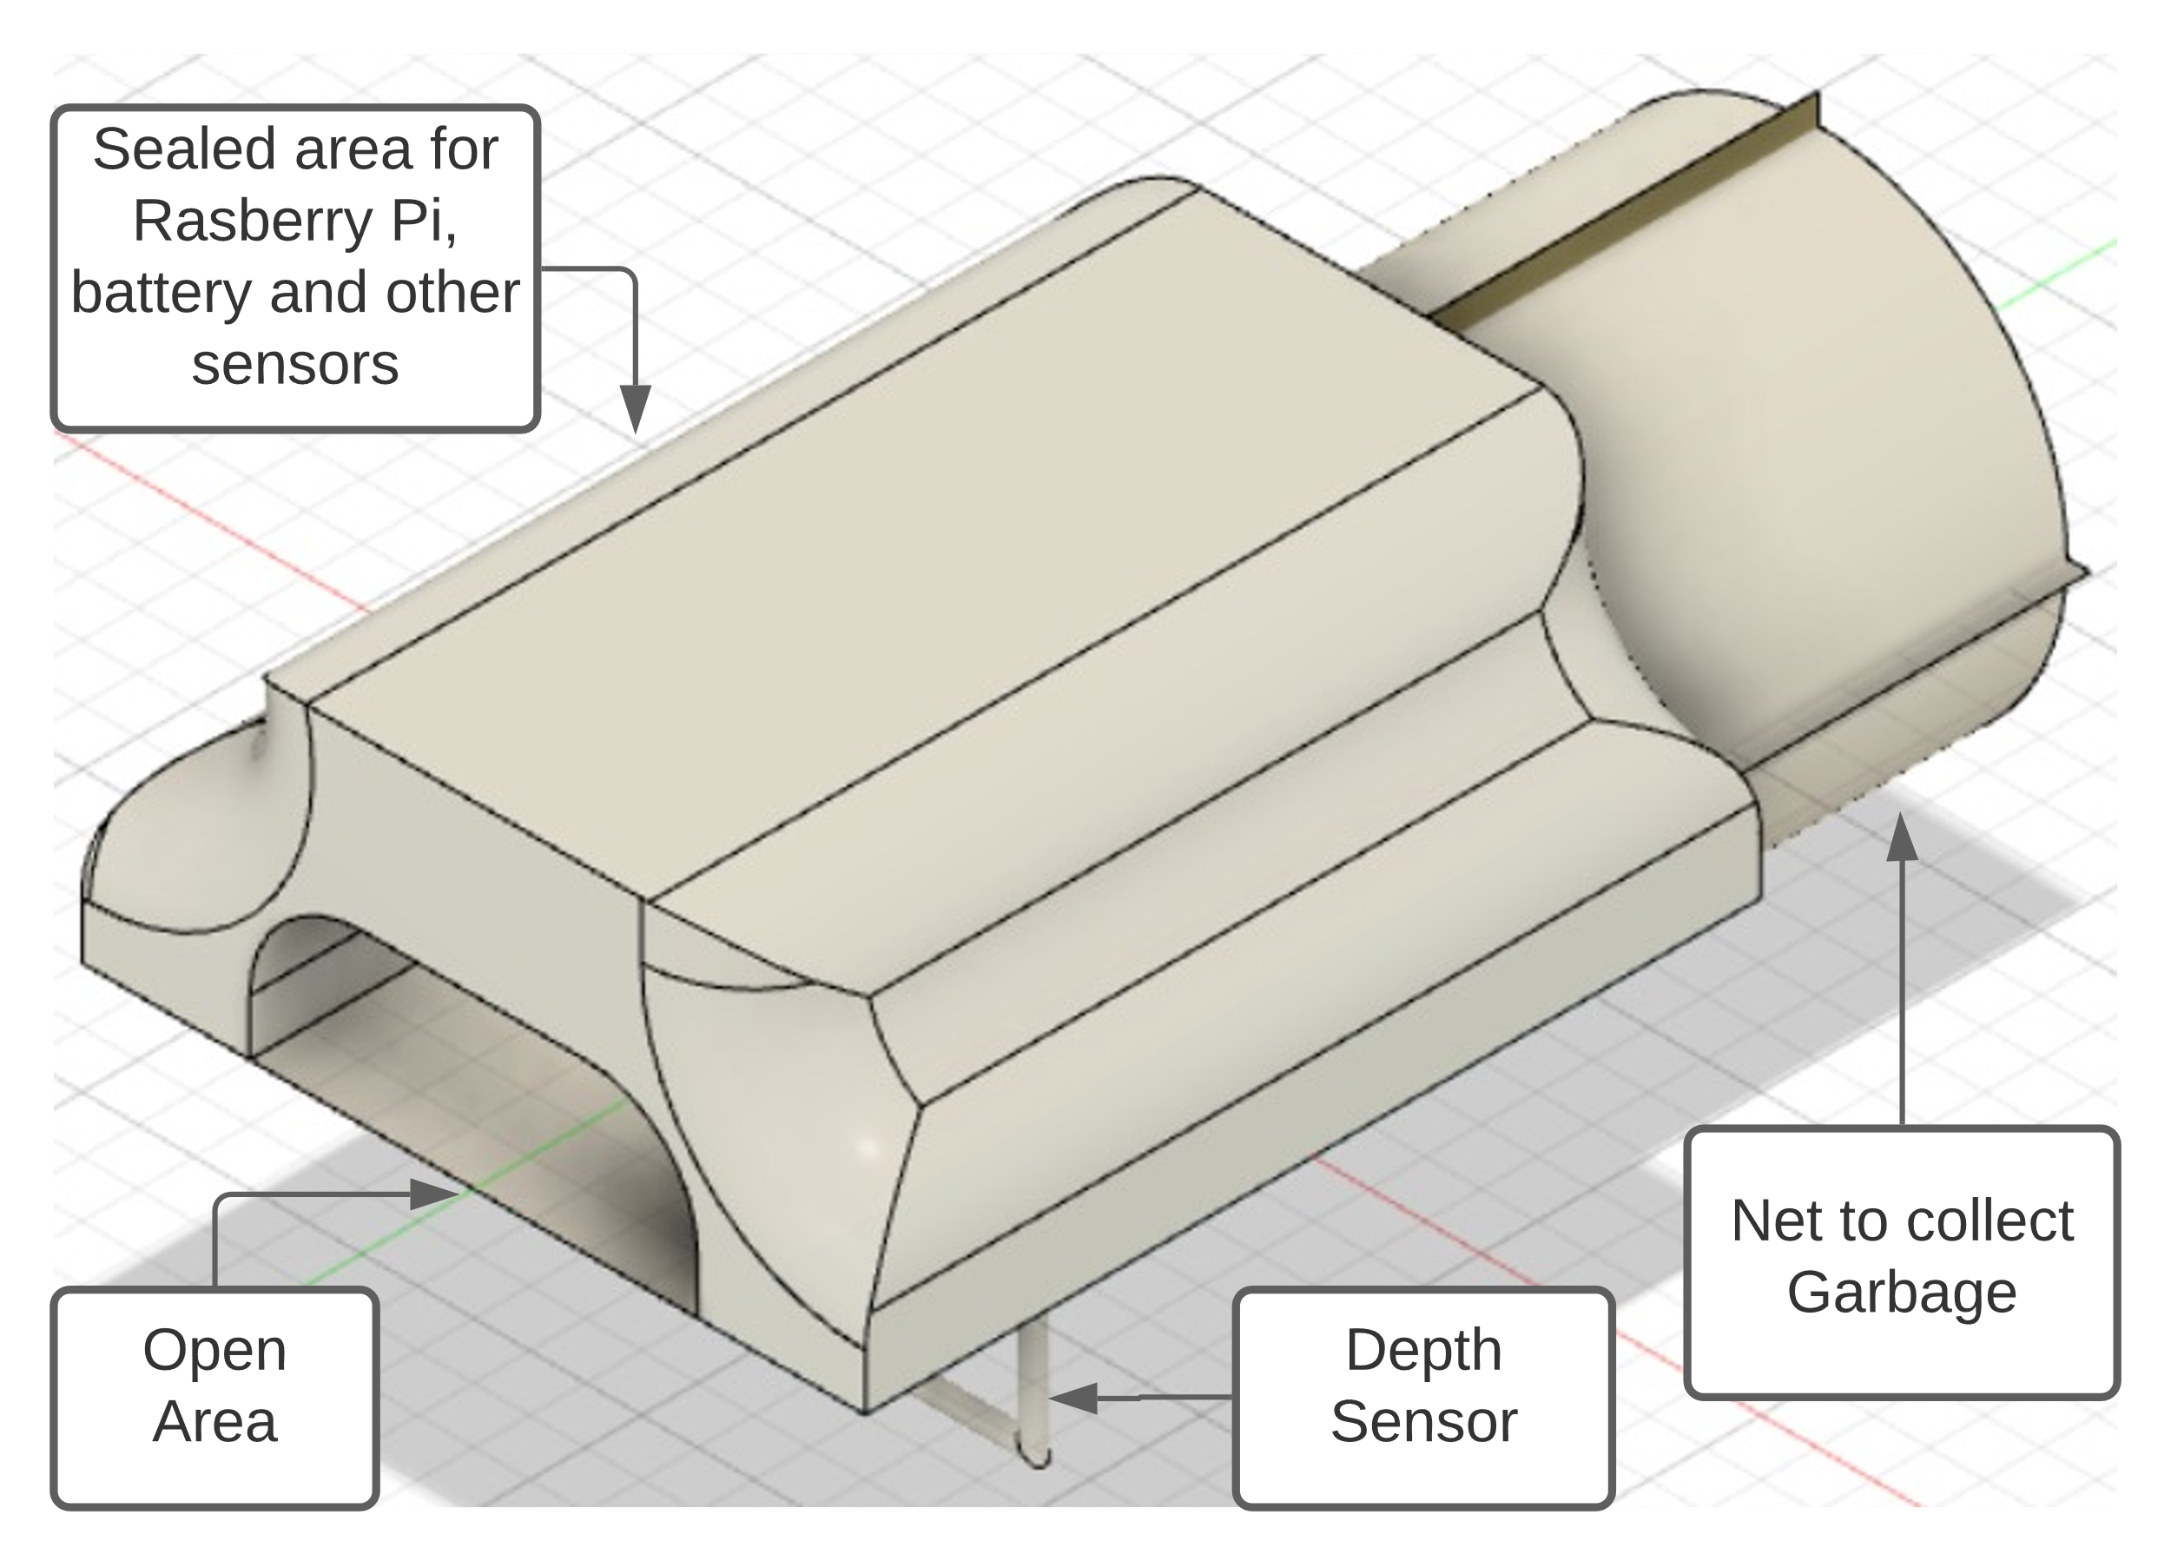

Figure 3: Orthographic projection of Model 1

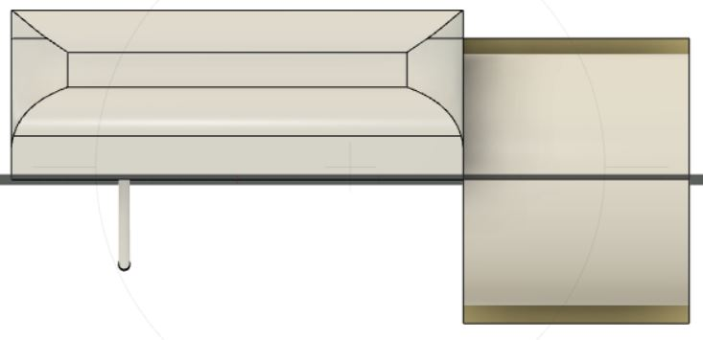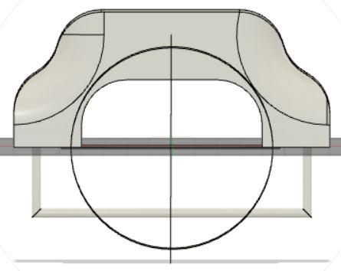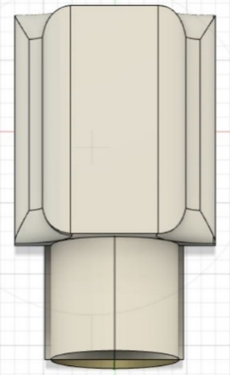

Figure 4, 5, 6: Left view, Front view and Top view of Model 1

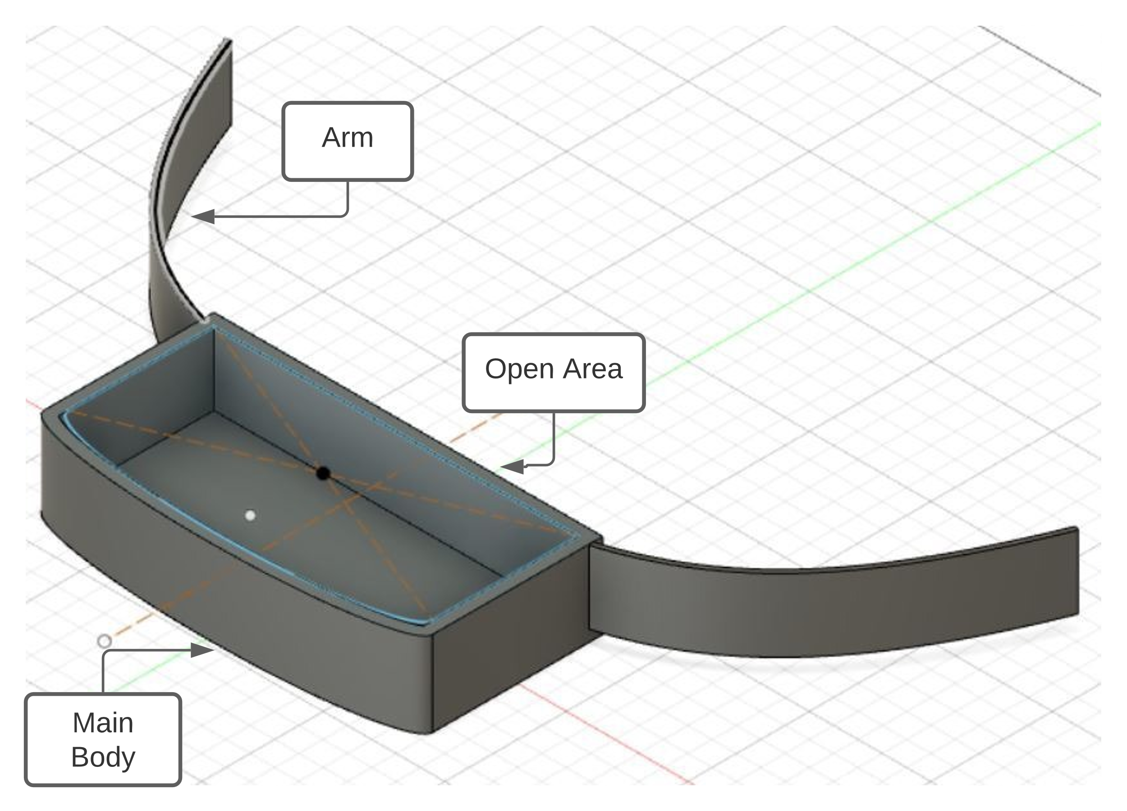

Figure 7: Orthographic Projection of Model 2

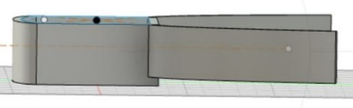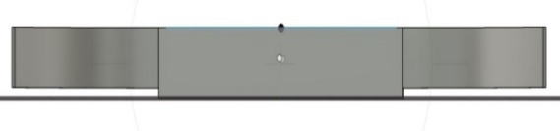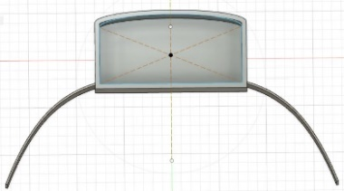

Figure 8, 9, 10: Left view, Front view and Top view of Model 2

**Electrical/Electronics and Mechanical Components:**

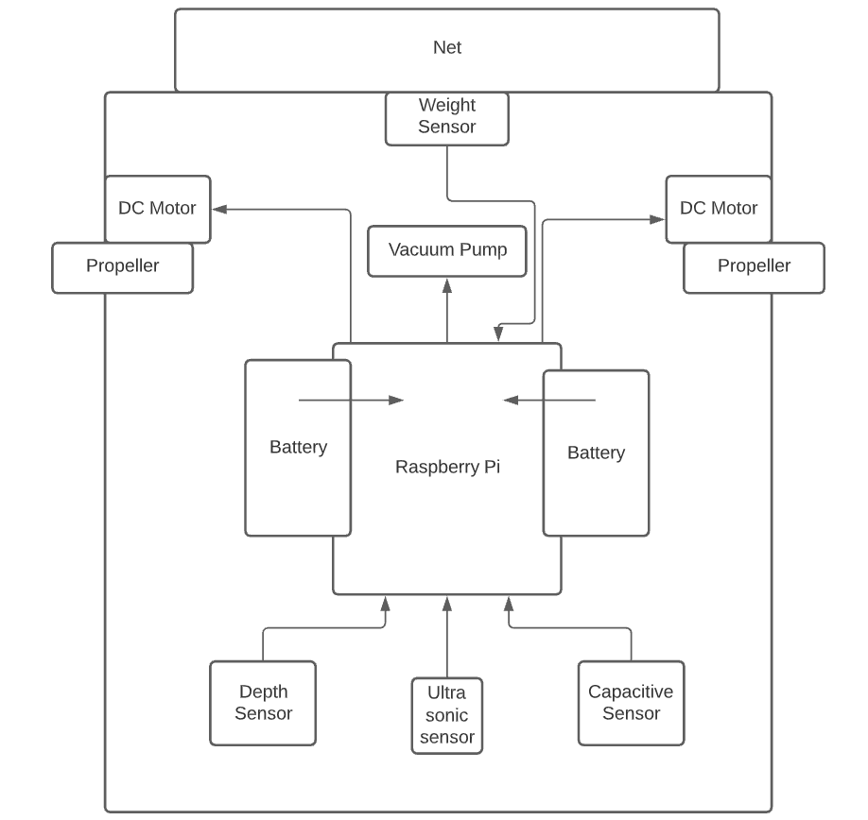

Figure 11: Overview of Mechanical and Electrical components

1. **Manufacturing Process description:**

**Production of Aluminium Sheets:** The sheet ingots or slabs used to make aluminium plates are first polished to give them the mirror-like brilliance that aluminium is known for. After being heated to 400°C, these are rolled through a rolling machine, resulting in a thin sheet of metal. This is referred to as hot rolling. In preparation for the next stage, the sheets produced here are rolled into coils.

Cold rolling is the next step for these aluminium sheets. This is where the sheets are flattened into various thicknesses to fit the numerous applications for which they will be utilised, as well as the requirements of diverse clients. These are likewise stored in rolls, similar to the rolls made after hot rolling.

Different varieties of aluminium sheets are generated on these rolls through various finishing methods. This is where annealing, surface treatments, and a variety of other processes take place.

**Sheet Shearing Machine (Hydraulic):** Cutting techniques include separating a piece of sheet metal by applying a sufficient amount of force to cause the material to fail. Shearing procedures are used to accomplish the most frequent cutting processes, which are sometimes referred to as shearing processes. When a large enough shearing force is applied, the material's shear stress exceeds its ultimate shear strength and at the cut location, the material will fail and separate. Two tools, one above and one below the sheet, apply the shearing force.

**Sheet Bending Machine (Hydraulic):** A bending machine is a tool for shaping metal. Its job is to put a bend on a workpiece together. During a linear or rotating movement, a bend is created by utilizing a bending tool.

**Die Punching Machine:** A punching machine is a machine tool for punching and embossing flat sheet-materials to produce form-features needed as mechanical elements and/or to increase the sheet section's static stability.

**Gas tungsten arc welding to join Aluminium sheets:** TIG welding is another name for tungsten inert gas (TIG) welding. To strike the arc with the workpiece, a non-consumable tungsten electrode is employed. Filler wire serves as a source of filler metal. At constant current, a non-consumable electrode produces a steady arc. Shielding gas such as Ar, He, or their mixtures offer shielding. Autogenous welds are possible with GTAW. It is feasible to produce high-quality welds with an excellent surface finish.

**3D Printing for small components:** To build a part, 3DP prints a binder into a powder bed. Only a small percentage of the component material is delivered through the printhead in 3DP; the majority of the part material is powder in the powder bed. Binder droplets (80 mm in diameter) often form spherical agglomerates of binder liquid and powder particles and bond to the previously printed layer. The powder bed is lowered and a new coating of powder is put onto it after each layer is printed. This procedure is repeated until the item, or array of parts, is finished (printing binder into bed; recoating bed with new layer of powder). 3DP has numerous parallel one-dimensional routes for patterning because the printer head comprises several ejection nozzles. The procedure is classified as a line-wise patterning process since it can be inexpensively scaled by simply increasing the number of printer nozzles. Due to the lack of a high-powered energy supply, fast deposition speeds can be achieved at a cheap cost. In the powder bed, 3DP pieces are self-supporting. In the powder bed, parts can be piled or arrayed.

1. **Assembly:** To connect the various electrical components, such as the PCB with Raspberry Pi, Raspberry Pi with Raspberry Pi camera, DC motor with motor driver module, ultrasonic, capacitive, and weight sensor with Raspberry Pi, servo robotic gripper with Raspberry Pi, jumper wires would be used. USB type A would be used to connect the Power bank with Raspberry Pi. Adhesive bonding can be used to connect propellers to DC motors for the mechanical portion.

**Adhesive bonding would be to bond 3D printed components and electrical components with Aluminium chassis:** Adhesives come in a variety of shapes and sizes, including liquid, paste, solution, emulsion, powder, tape, and film. Adhesives are typically 0.1 mm thick when applied.

**Surface preparation:** The absence of dirt, dust, oil, and other contaminants determines the adhesive bonding strength. Contaminants also affect the adhesive's wetting ability, making it impossible for it to spread evenly across the interface.

**Process capabilities:** Used to join a wide range of metallic and nonmetallic materials that are both comparable and dissimilar. Different shapes, sizes, and thicknesses of components. To strengthen the bond's strength, adhesive bonding can be supplemented with mechanical joining methods. Fixtures, presses, tooling, as well as autoclaves and ovens for curing, are typically required.

**Limitations and Challenges:**   
1) Can hold limited amount of weight at a time.  
2) Cannot capture huge plastic objects.  
3) If garbage gets stuck in the vacuum passage, then capturing of garbage is challenging.  
4) Identifying if any object is plastic trash or not.   
5) Making a design that has proper aero dynamics, center of mass, and center of buoyancy.

1. **Scope of improvement:**

* The increased length of arms would lead to an increased rate of collisions, so better design could be made.
* Deep learning model could be implemented along with computer vision so as to avoid any kind of harm to the aquatic flora and fauna.
* The increased weight due to the extra segment at the front can lead to imbalance of bot thus can lead to sinking; this can be improved by a better design.
* Separate floating and underwater components would help us to collect garbage at higher speed.
* The garbage is collected and stored inside the bot instead of a net to avoid drag.
* May not be able to distinguish between plastic from other substances present in the water bodies so a proper deep learning model is needed.
* A simpler design of the bot would be helpful to be able to easily incorporate the changes which we want.

1. **Scheduling plan:**  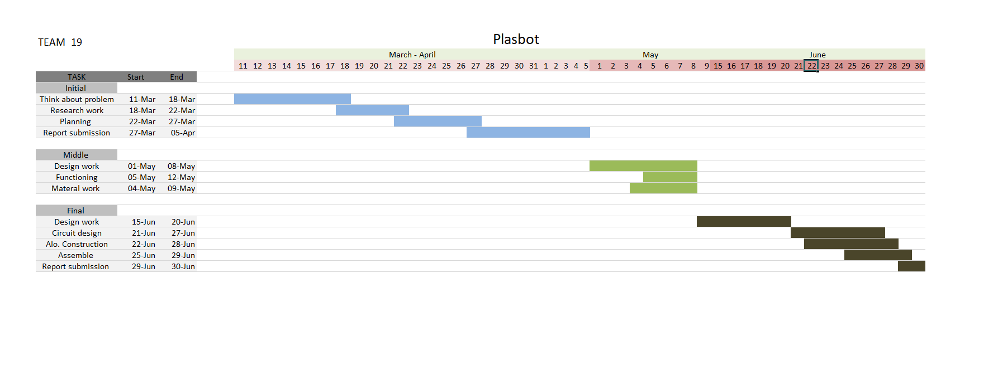

Figure 12: Gantt Chart

1. **Contribution:**

**Chapter 1:** Tanmay, Ayuj, Piyush

**Chapter 2:** Nikhil, Sourav, Pritish

**Chapter 3:** Sourav, Pritish

**Chapter 4:** Tanmay, Piyush

**Chapter 5:** Ayuj, Nikhil

1. **Conclusions:**  As the level of plastics garbage is increasing in water bodies, it is very difficult for marine life to survive. To tackle this problem, we have created a semi-automatic bot named ‘PlasBot’ which can detect as well as collect plastic garbage from water bodies. It is designed to collect garbage from both on surface and deep underwater. The collected garbage is stored in chamber and as the capacity of chamber reaches its limit the bot stops collecting and travels near to the water bodies bank for garbage to be disposed off. It saves a lot of time, money, manpower and cleans the environment (water bodies). In future, the bot can be made more compact as well as the capacity to collect garbage can be increased. It also can further be modified for automatically deep cleaning.

**References**

* Author: Omnipresent Robot Tech Site: [Ro-Boat](http://www.omnipresenttech.com/cleaningsolutions.php)
* Author: Financial Express Site: [Kerala’s sewage cleaner robot](https://www.financialexpress.com/industry/kerala-start-ups-sewage-cleaner-robot-attracts-big-attention/1127538/)
* Author: The Logical Indian Site: [Clearbot](https://thelogicalindian.com/environment/hong-kong-startups-solar-powered-aquatic-robot-to-clear-trash-from-water-bodies-runs-for-48-hours-in-single-charge-26676)
* Author: Dyson Site: [ORCA:China’s river cleaning robot](https://medium.com/dyson-on/orca-chinas-river-cleaning-robot-929ce62269c4)
* Author: Water Botics Site: [Seaswarm](https://waterbotics.org/real-robots/cleanup/)
* Author: Nameplates Site: [Aluminium Plates and Sheets](https://nameplatesdiv.com/how-aluminum-plates-and-sheets-are-made/)
* Author: Dr. Sunny Zafar *referred from* IC141 Product Realization Technology Lectures.
* Author: Dr. Prateek Saxena *referred from* IC201P Design Practicum Lecture Monday, 12th April 2021.